Github Link:

Project Title: Forecasting house prices accurately using smart regression techniques in data science
____________________________________________________________________________

Student Name: Roopasri S
Register Number: 513523205035
Institution: Annai Mira College of Engineering and Technology
Department: B.Tech Information Technology
Submission Date : 2-5-2025

1.Problem Statement
Forecasting house prices is a critical task in the real estate industry, enabling stakeholders such as buyers, sellers, investors, and policymakers to make informed decisions. Traditional methods often fall short in capturing complex, non-linear relationships between property features and prices. This project aims to develop a smart regression-based predictive model using advanced data science techniques to analyze and predict house prices. The objective is to enhance prediction accuracy by leveraging machine learning algorithms that can learn from historical data, identify patterns, and adapt to diverse housing markets.

2. Project Objective
● Choose the important features that affect house prices.
● Understand data patterns through analysis.
● Build models using smart regression techniques.
● Check and improve model accuracy.
● Compare models to find the best one.

3. Flowchart of the Project Workflow
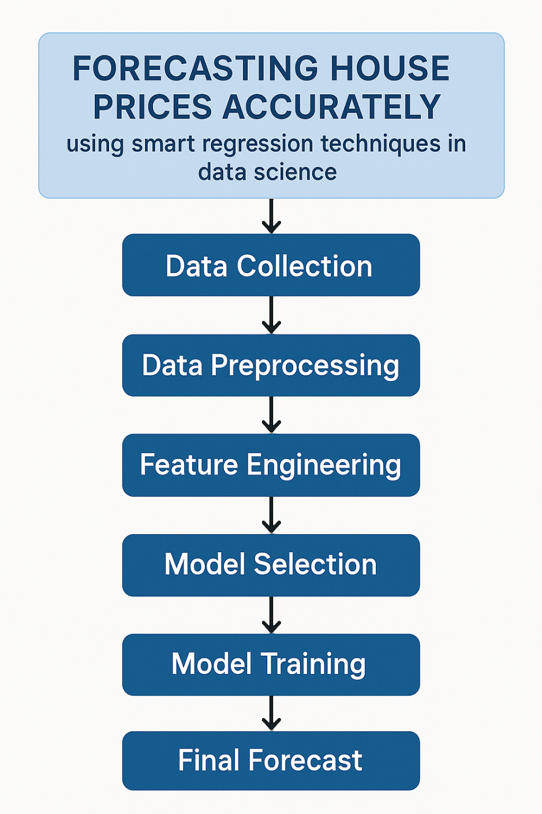
4. Data Description
- Location: Neighborhood, Latitude, Longitude
- Size: Lot area, Living area (GrLivArea)
- Structure: House style, Year built, Total rooms, Bathrooms
- Quality: Overall quality & condition (1–10 scale)
- Amenities: Garage area/type, Fireplaces, Pool area
- Target: SalePrice — the house price to predict.

5. Data Preprocessing
- Handle Missing Values: Impute or drop missing data.
- Encode Categorical Features: Use label or one-hot encoding.
- Normalize/Scale Numeric Features: Use Min-Max or Standard Scaler.
- Outlier Treatment: Remove or cap extreme values.
- Feature Engineering: Create new features (e.g., house age).
- Split Data: Train-test split (e.g., 80-20).

6. Exploratory Data Analysis (EDA)
- Summary Statistics: Mean, median, std, min, max.
- Missing Value Check: Visualize with heatmaps or count nulls.
- Distribution Analysis: Histograms for price & numeric features.
- Correlation Matrix: Identify relationships (e.g., heatmap).
- Outlier Detection: Use boxplots for key features.
- Feature Relationships: Scatter plots (e.g., price vs. areas)
7. Feature Engineering
- House Age = Current Year - YearBuilt
- Total Bathrooms = FullBath + 0.5 × HalfBath
- Total SF = 1stFlrSF + 2ndFlrSF + TotalBsmtSF
- IsRemodeled = 1 if YearRemodAdd ≠ YearBuilt
- Price per SqFt = SalePrice / GrLivArea
- Neighborhood Encoding = One-hot or label encoding

8. Model Building
- Select Algorithms:
  - Linear Regression
  - Ridge/Lasso Regression
  - Random Forest
  - Gradient Boosting (e.g., XGBoost)
- Train Models: Fit models on training data.
- Cross-Validation: Use k-fold CV to avoid overfitting.
- Hyperparameter Tuning: Use GridSearchCV or RandomizedSearchCV.
- Evaluate Performance: Use RMSE, MAE, R² on test set.
- Select Best Model: Based on performance metrics.
9. Visualization of Results & Model Insights
Feature Importance -
- Bar charts showing which variables most impact house prices.
Regression Line Plot –
- Visualizing predictions vs. actual values to assess accuracy.
Residual Plot –
- Checking errors in predictions to ensure robustness.
Price Distribution Histogram –
- Understanding price trends in different regions.
Scatter Plot of Key Predictors –
- Illustrating how factors like square footage or location affect price.
10. Tools and Technologies Used

List of tools and technologies are below:

● Pandas and numpy– For data manipulation and numerical operations.

● Scikit-learn – For regression models and evaluation.

● XGBoost / LightGBM – Advanced regression algorithms for better accuracy.

● Matplotlib & Seaborn – For data visualization.

● Jupyter Notebook – For interactive development and testing.

● Flask / Streamlit – To build a simple web app for predictions.

● Git & GitHub– For version control and collaboration.

11. Team Members and Contributions
Raksha K – Team Leader
- Manages the project schedule, assigns tasks, and ensures team coordination.
Ranjana R – Data Collection & Cleaning
- Finds relevant datasets and prepares the data for analysis.
Roopasri S – Model Building & Testing
- Works on applying and testing regression models for prediction.
Praveena V – Report & Presentation Preparation
- Prepares the project documentation, report, and PowerPoint slides.
Naveen Kumar P – App Interface & Integration Support
- Helps create a simple interface and supports connecting the model to the front end.

